TEXT 1

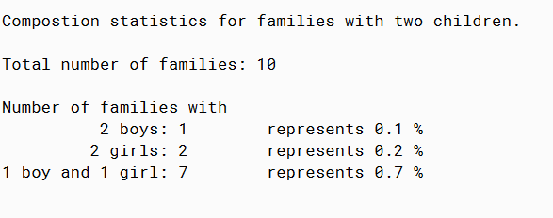

TEXT 2

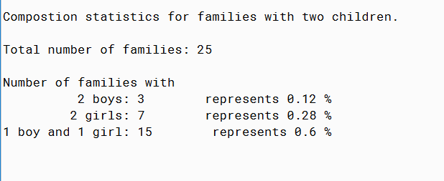

MALE FEMALE IN FAMILY

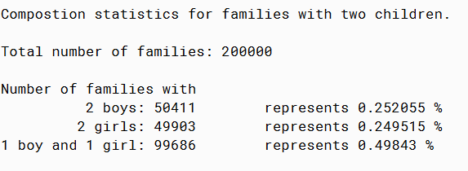

PMR: This program was actually kinda challenging. First it took me a while that I needed to import other files. In general the code was difficult to build and it did require research on the internet.

/\*\*

\* Reads text in from a file and calculates the probability of family combinations

\* from the given data.

\*

\* @author Anika Jallipalli

\* @version 10/20/2019

\*/

import java.util.Scanner;

import java.io.File;

import java.io.FileReader;

import java.io.IOException;

public class Family

{

public static void main(String[] args) throws IOException {

//initialize variables

int bothBoys = 0;

int bothGirls = 0;

int boyAndGirl = 0;

int sampleSize = 0;

int counter=0;

double probabilityOfBothBoy=0;

double probabilityOfBoyAndGirl = 0;

double probabilityOfBothGirl =0;

String token = "";

Scanner inFile = new Scanner(new File("maleFemaleInFamily.txt"));

while(inFile.hasNext()){

token = inFile.next();

if(token.equals("BB")){

bothBoys++;

counter++;

}else if(token.equals("GG")){

bothGirls++;

counter++;

}else if(token.equals("BG")){

boyAndGirl++;

counter++;

}else if(token.equals("GB")){

boyAndGirl++;

counter++;

}

}

sampleSize = counter;

inFile.close();

probabilityOfBothBoy = (double)bothBoys / (double)sampleSize;

probabilityOfBothGirl = (double)bothGirls / (double)sampleSize;

probabilityOfBoyAndGirl = (double)boyAndGirl / (double)sampleSize;

System.out.println("");

System.out.println("Compostion statistics for families with two children.");

System.out.println("");

System.out.println("Total number of families: " + sampleSize);

System.out.println("");

System.out.println("Number of families with");

System.out.print(" 2 boys: "+ bothBoys);

System.out.println(" represents "+ probabilityOfBothBoy + " %");

System.out.print(" 2 girls: "+ bothGirls);

System.out.println(" represents "+ probabilityOfBothGirl + " %");

System.out.print("1 boy and 1 girl: "+ boyAndGirl);

System.out.println(" represents "+ probabilityOfBoyAndGirl + " %");

}

}